http://165.22.217.185/layout/Product
Editing product shows “NAN” in pts, ptr calulations.
Editing product sometimes disables IGST.
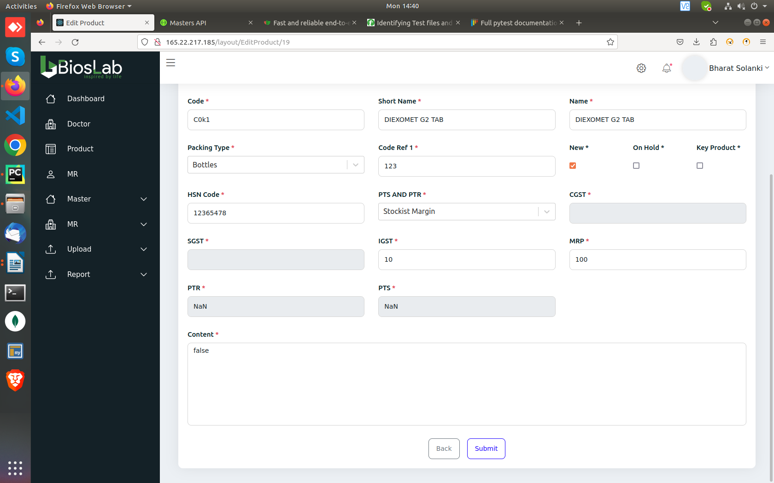
http://165.22.217.185/layout/Product
Editing Product calculates PTS PTR after giving the
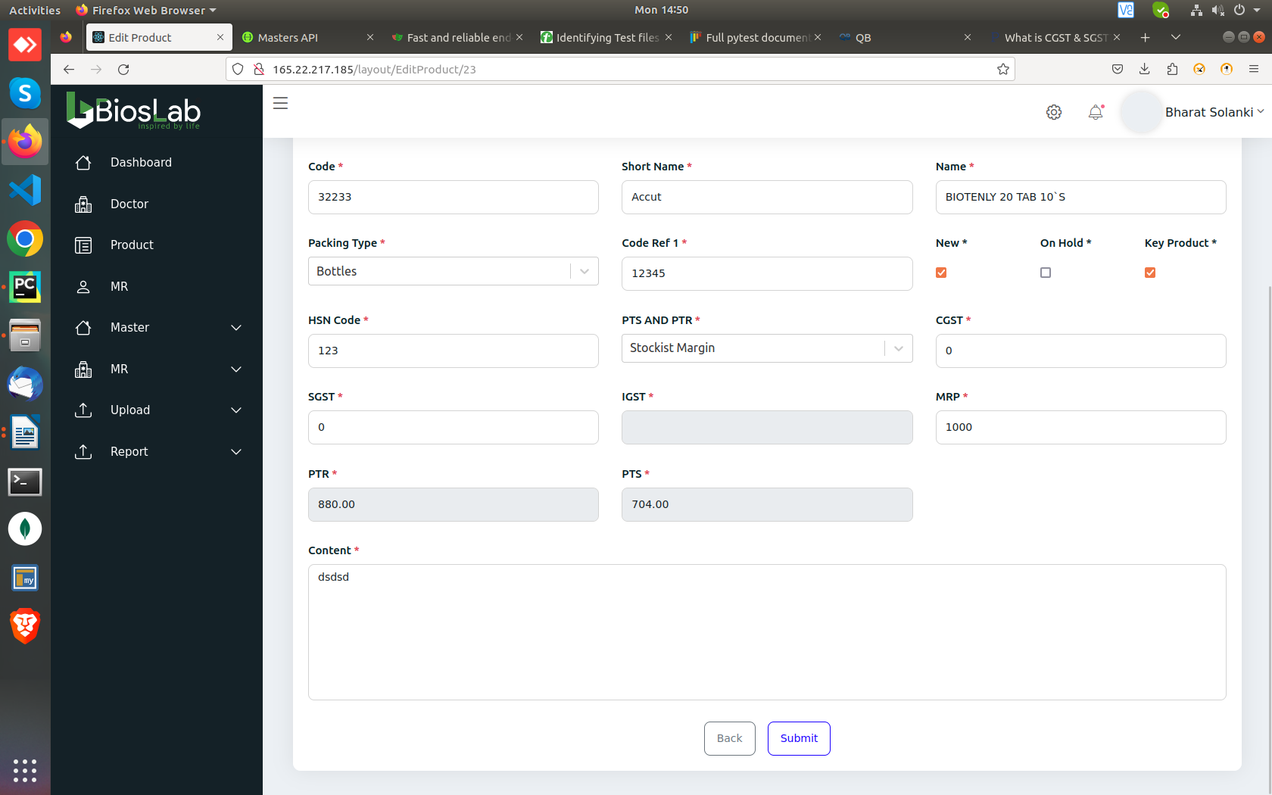
values “0” in CGST SGST

http://165.22.217.185/layout/Product
Improper error message in SGST.

http://165.22.217.185/layout/Product
Allows to keep either sgst or cgst to be “0”

http://165.22.217.185/layout/Product

We can create duplicate prodcuts of same “Product Code” by giving a blank space at the end of the product code.

http://165.22.217.185/layout/Product
In edit product, if we delete the product class, we can update the field without selecting product class
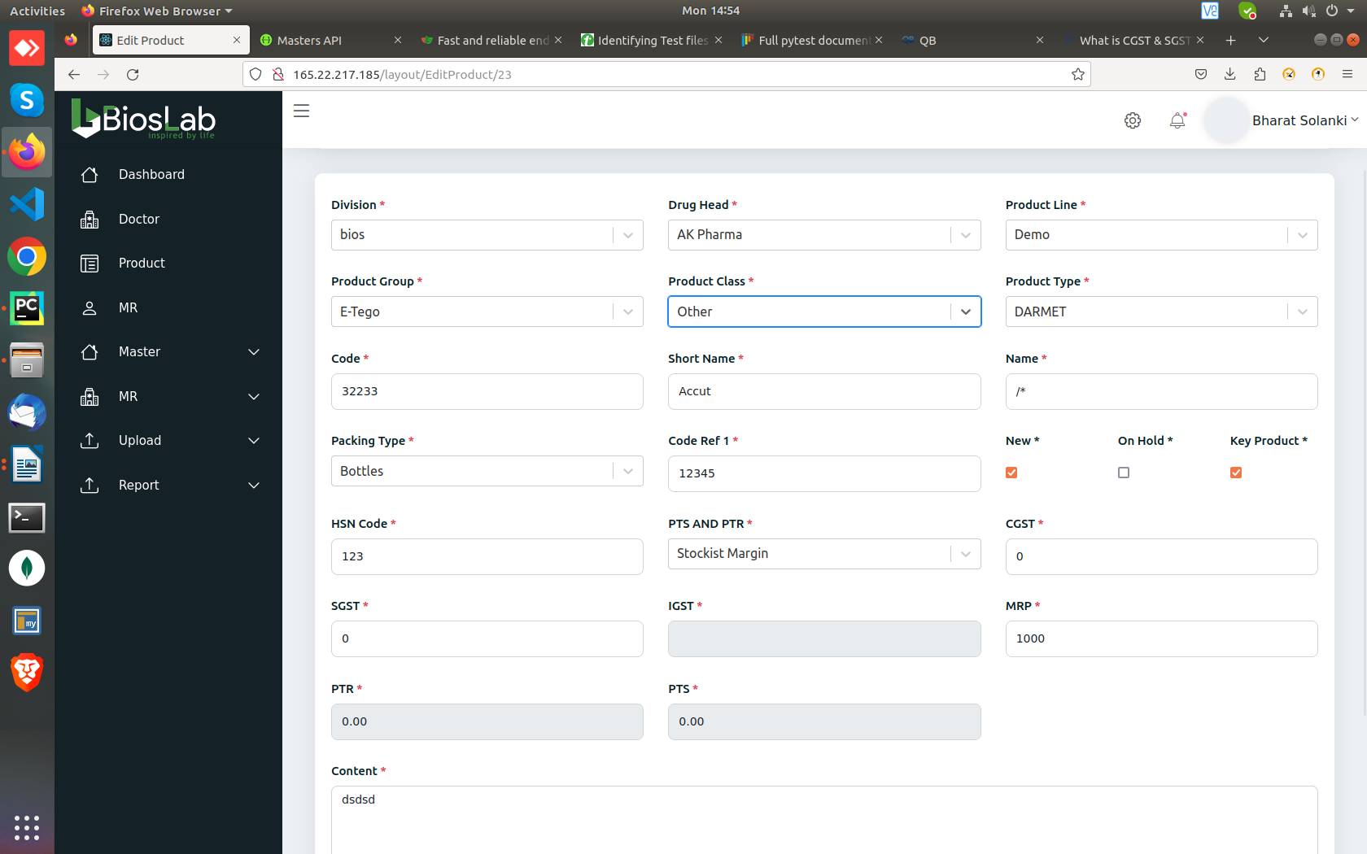

http://165.22.217.185/layout/Product

While creating a new product group, if we click delete, it shows the “Add Product” and “Delete Product” instances together.

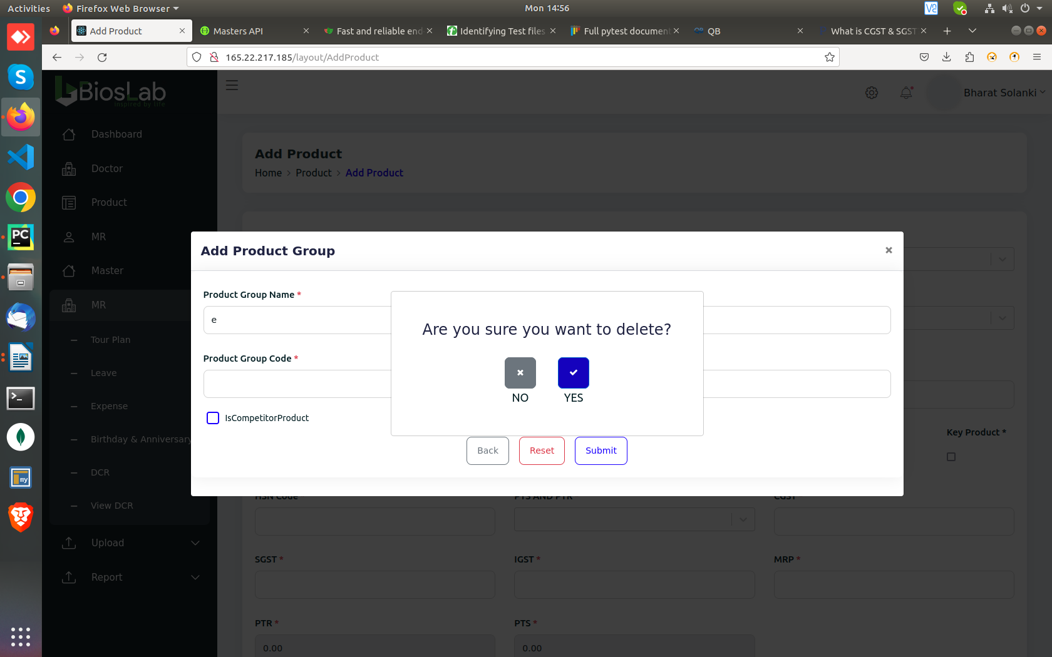
http://165.22.217.185/layout/Product

After inputing “Code ref 1” if we Press the “Tab” to select the checkbox, it doesn’t show it’s current position.

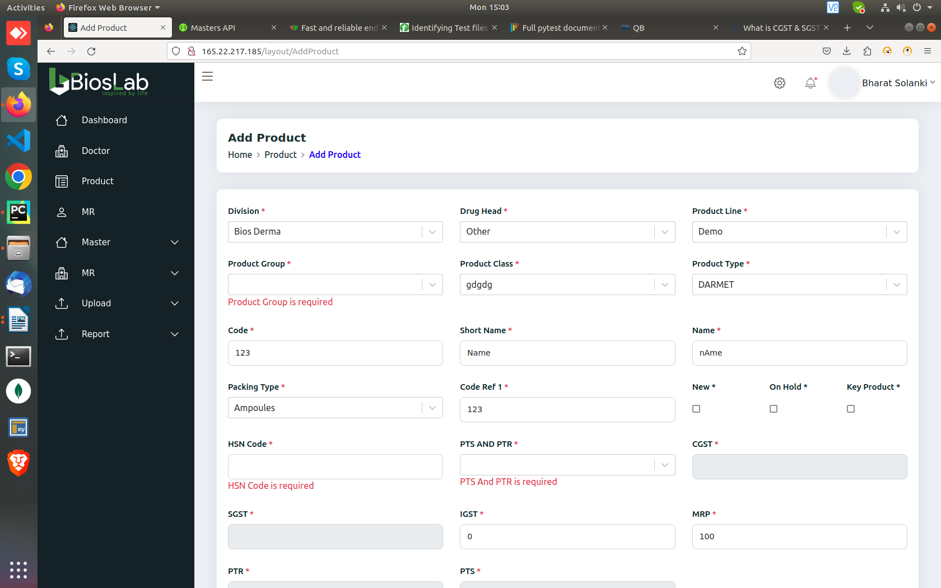
http://165.22.217.185/layout/Product

The values of “PTS” and “PTR” shown in the data grid is different from the values shown in the “Edit”

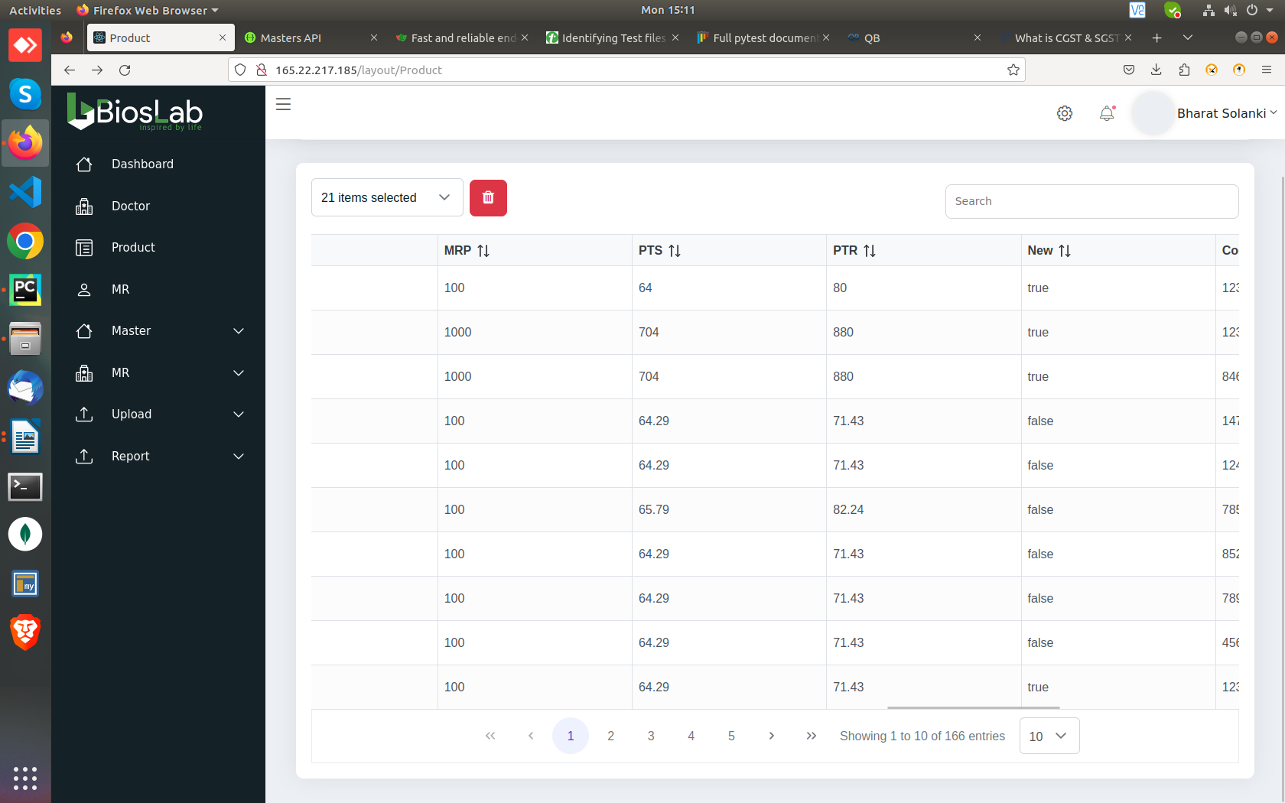
http://165.22.217.185/layout/Product
Allows to keep SGST and CGST of different values.
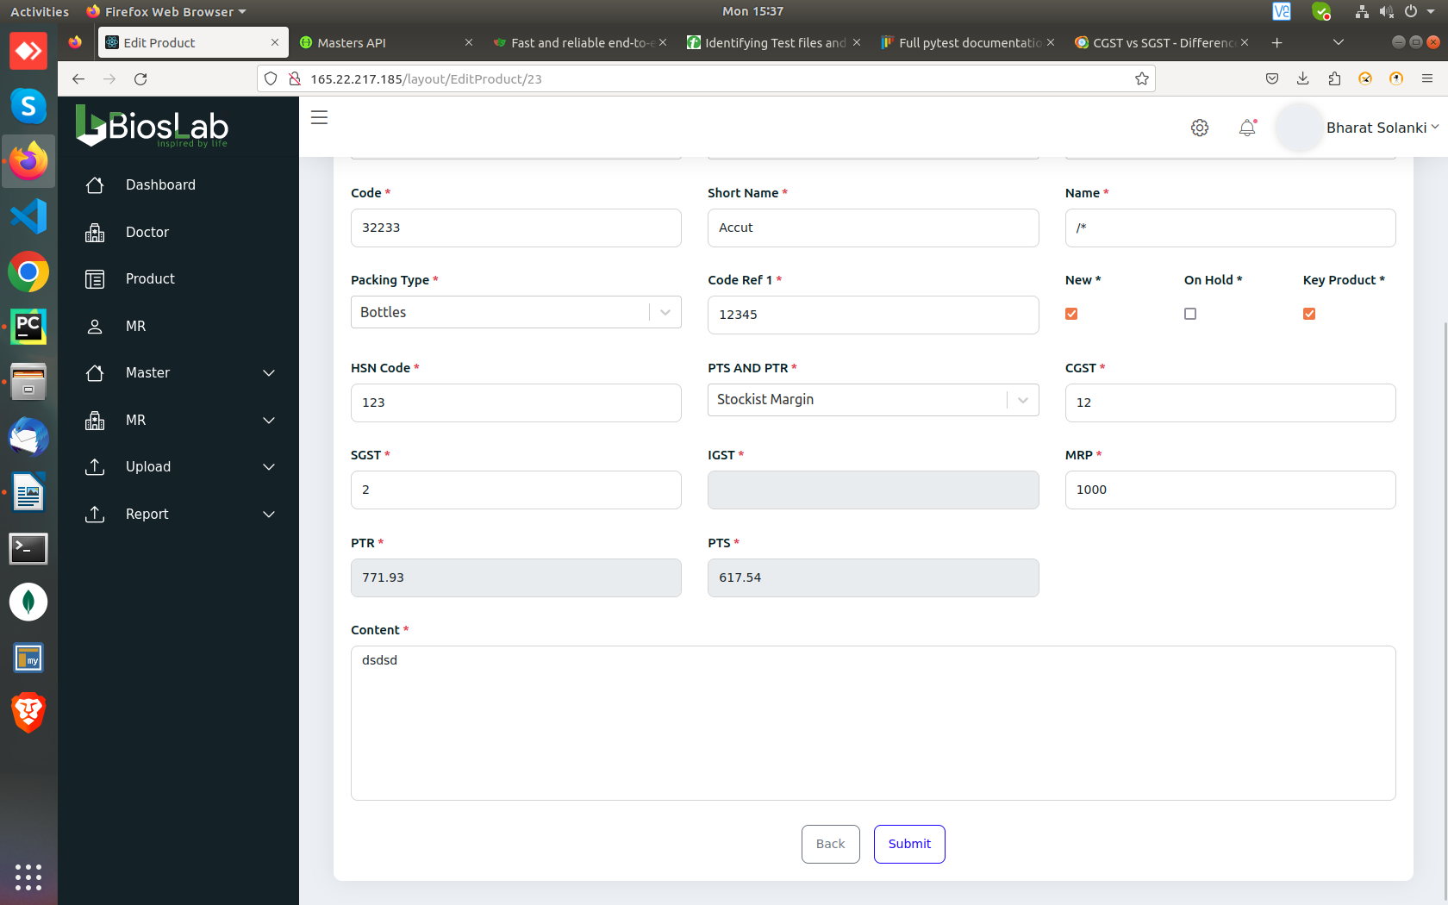
http://165.22.217.185/layout/doctor
“Website” field validation is not present in “Add doctor”

http://165.22.217.185/layout/doctor
“The JSON value could not be converted to System.Int64”
while adding a category with a blank name.
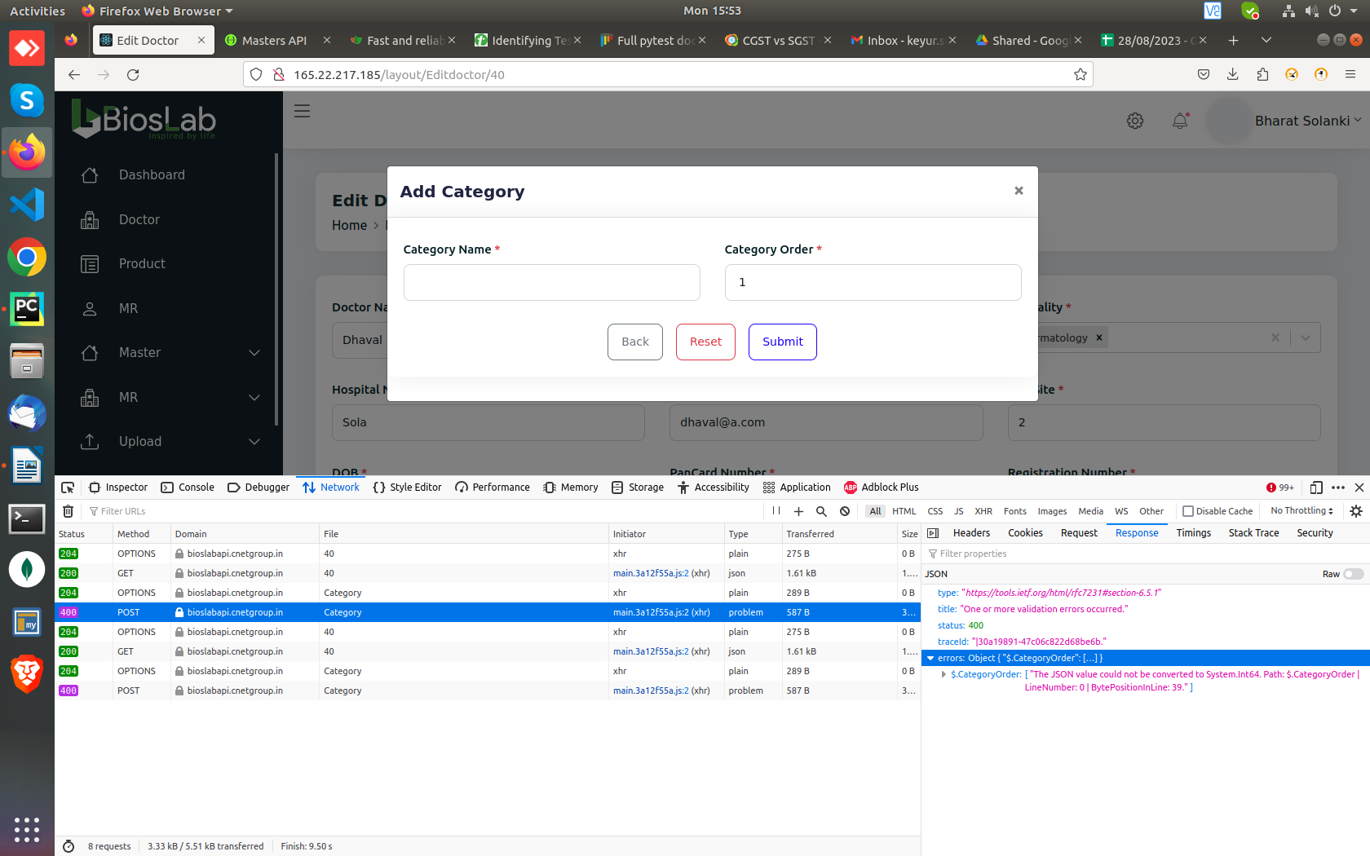
http://165.22.217.185/layout/doctor
Allows the number of “Daily patients” to be greater than “weekly” and “monthly” patients.
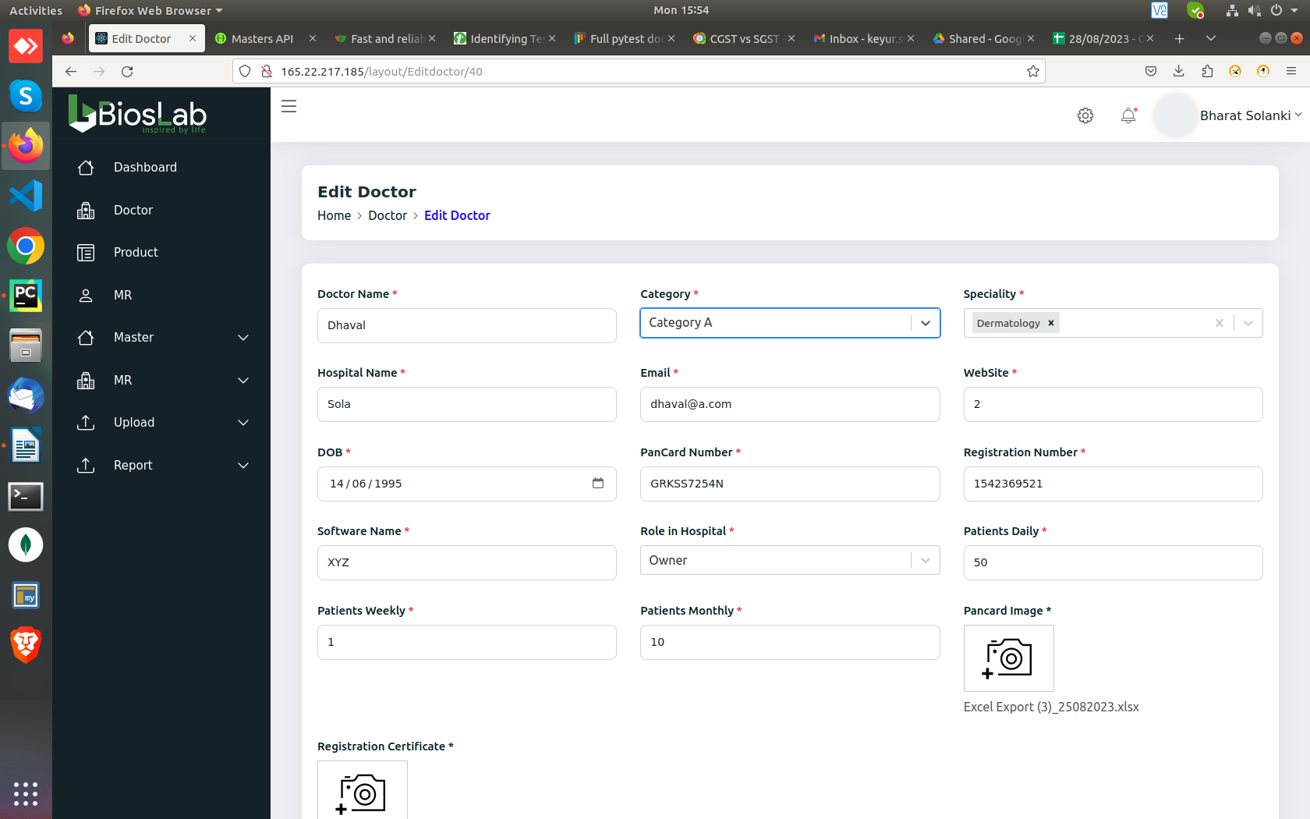
http://165.22.217.185/layout/master/RCPA/CompetitorMst
Accepts blank space in “Location” and “Description”

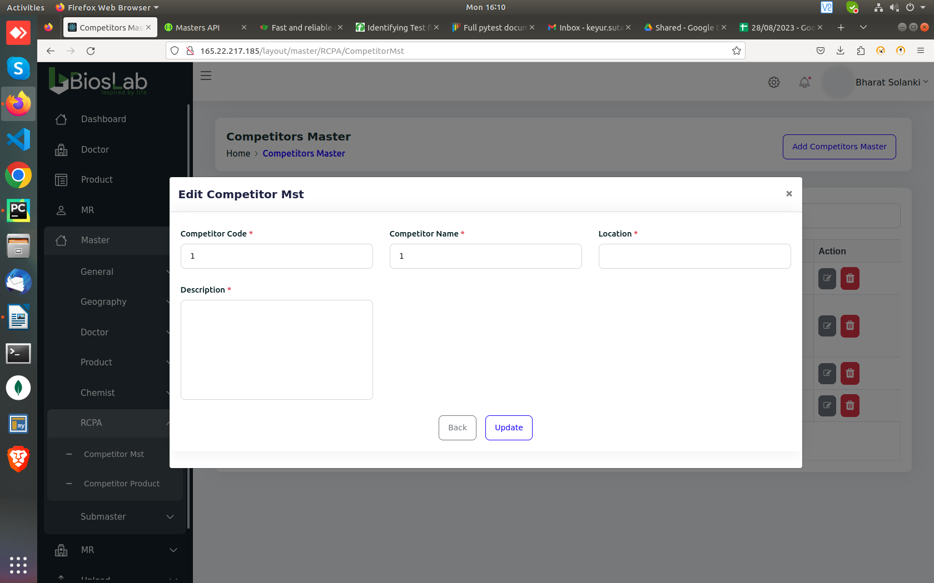
http://165.22.217.185/layout/master/RCPA/AddCompetitorsProduct
Reset button doesn’t reset the dropdowns.
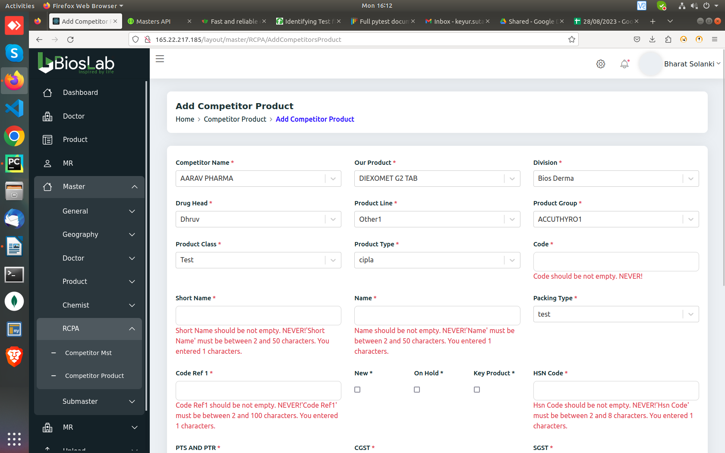
http://165.22.217.185/layout/master/general/CFA
Editing CFA throws error in PINCODE ID. Same error also gets reflected in stockists(http://165.22.217.185/layout/master/general/Stockiest)
“The JSON value could not be converted to System.Int64. Path: $.PinCodeId”
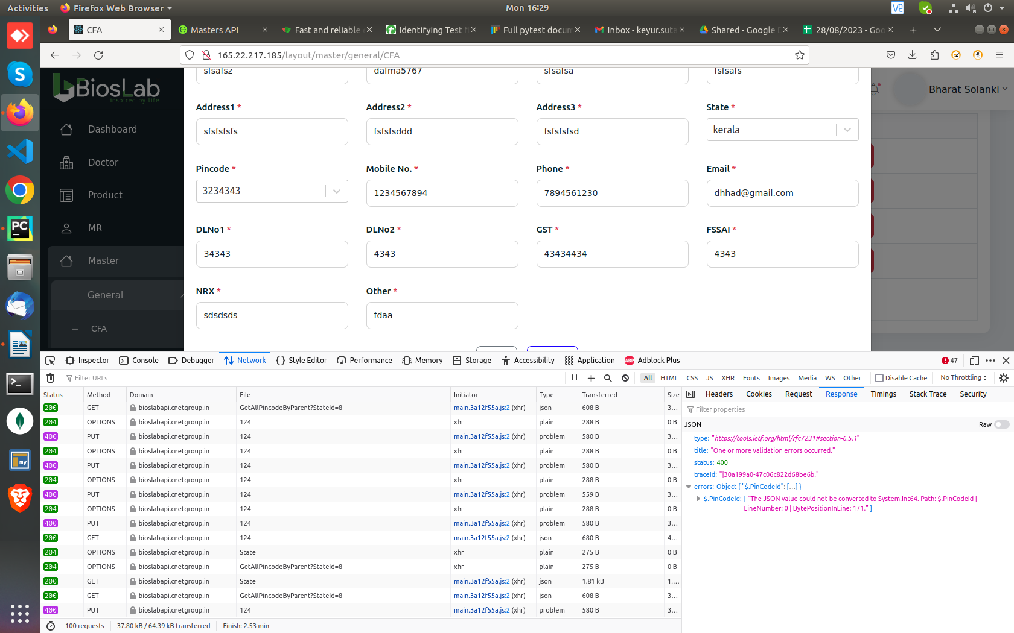

http://165.22.217.185/layout/master/general/CFA
Accepts blanks spaces in GST and FSSAI
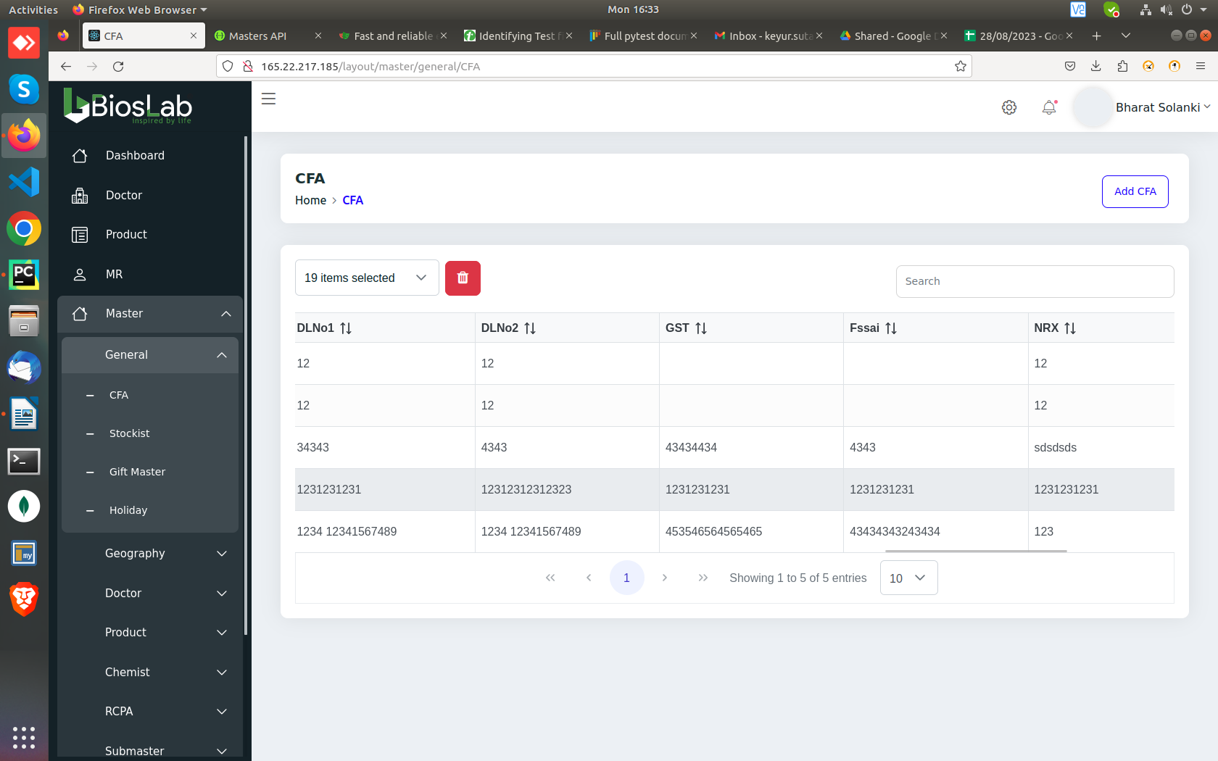

http://165.22.217.185/layout/master/general/Stockiest
can’t desselects “Action” and “Creation date”
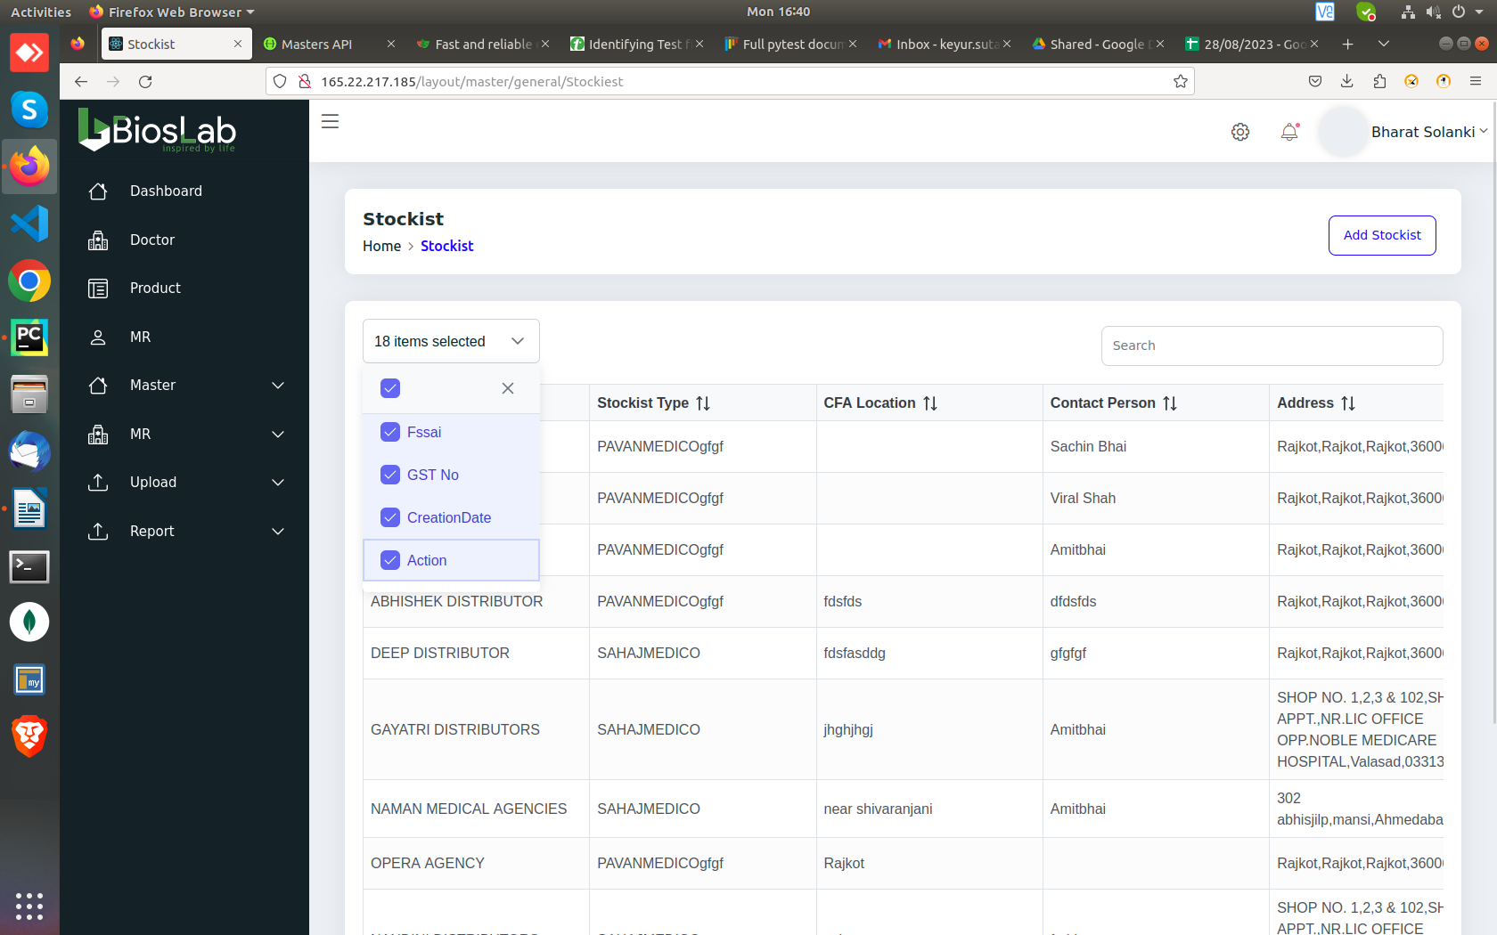
Other Common Bugs:

Desselecting the “ACTIONS” option from the data grid dropwdown options, changes the way grid looks(Rows get crammed up)
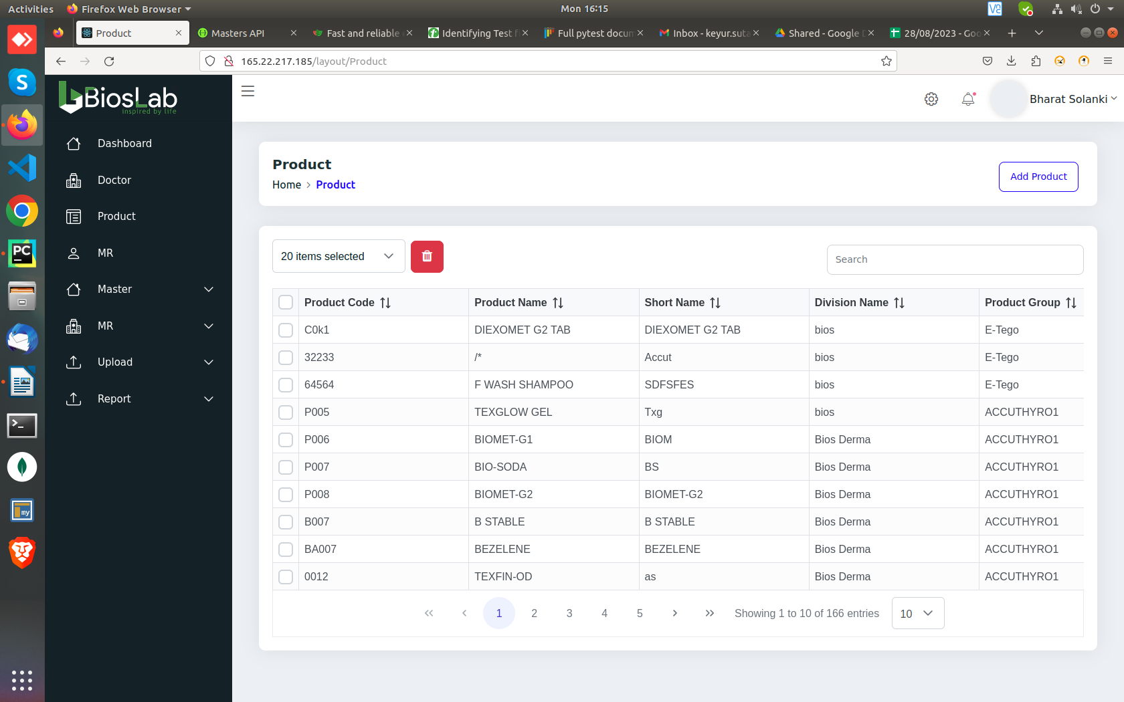

Let’s enter 5 digit values in year and throws this error.
"The JSON value could not be converted to System.DateTime. Path: $.Date”

Data grid delete button missing from:
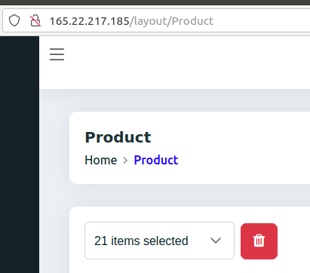

Doctor
MR
Master—General--stockist
Master—General—Gift Master
Master-General—Holiday
Master—Geography
Master—Doctor—speciality and qualification

